**Plotting the best fitting line**

ggplot()+

geom_point(data=dat, aes(x=x, y=y))

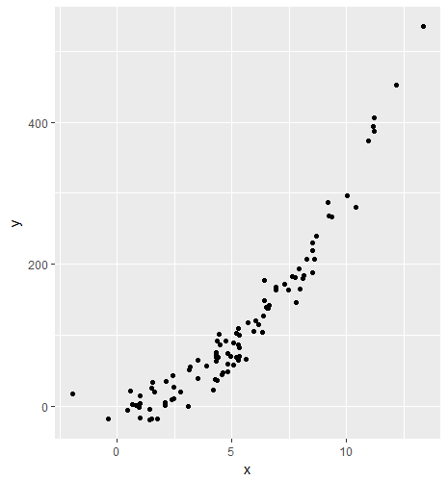

We will find the best fitting line using lm function

> lm(y~x, data=dat)

Call:

lm(formula = y ~ x, data = dat)

Coefficients:

(Intercept) x

-65.27 34.04

x1 <- function(x){

34.04*x-65.27

}

ggplot()+

geom_point(data=dat, aes(x=x, y=y))+

stat_function(data=data.frame(x=c(-5, 15)), aes(x=x), fun=x1)

